Assignment 1: Huggingface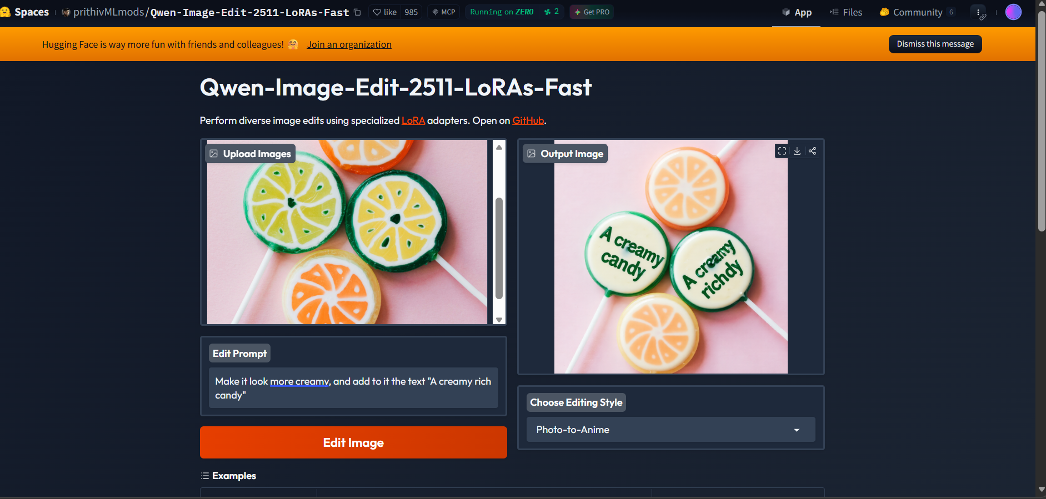

Assignment 2: Kaggle
https://www.kaggle.com/datasets/benitoitelewuver/population-and-demography-dataset

Having extensive demographic data is crucial for a statistician because it enables precise analysis, modelling, and prediction of population trends and social patterns. The fact that I studied statistics and am currently studying demography makes this topic of interest to me.

Assignment 3: Google Colab
